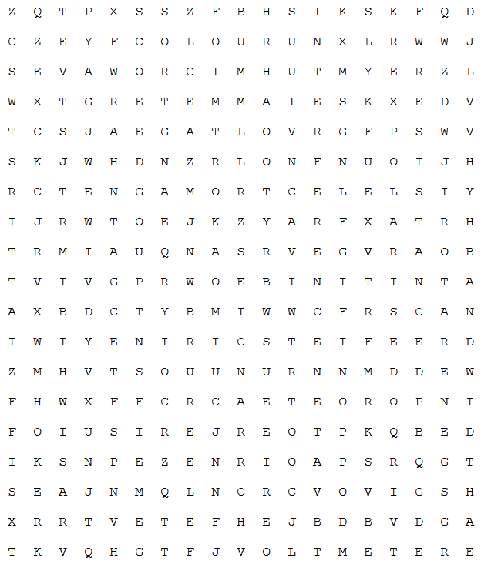
Ammeter | Generator | Resistance
Bandwidth | Interference | Transformer
Circuit | Internet | Turbine
Colour | Iridescence | Voltage
Current | Microwaves | Voltmeter
  Dispersion | Motor | X-ray
Electromagnet | Ohm
Fuse | Polarised

